Barry Cullen Photo Poster prize

2025

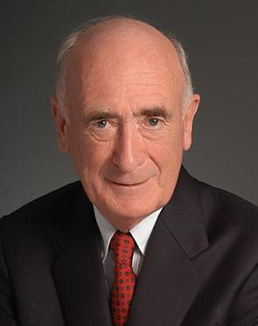

James “Barry” Cullen was a titan of Ophthalmology. He worked in Edinburgh as a Neuro-Ophthalmologist until his first retirement in 1994 and then in Singapore until 2015. Described as like the Pied Piper of Ophthalmology, he inspired so many subsequent Ophthalmologists around the globe.

He died in September 2020 at the age of 92.

**February 2025 will see the start of a new category of poster at the SOC**

* Case report of a clinical nature
* Emphasis on images
* The text should be short and concise
* There will only be 5 posters accepted
* The best poster as judged on the day will get £500 towards buying a piece of ophthalmic equipment for themselves
* **Limited to junior ST(1-2)s, FY’s , medical students and non medical ophthalmic staff**